,ElRtg&H.w>upD.…..
rfeH.xD.oD[JpdmM>okw>ol.zSHo;nDwuh>
y'k;oh.eD.b.okvXw>zSD.v.wz.tHR
rk>,J>eHRrh>w>uX.cd.ovk;rk>eHR

rk>weHR[DvH;'h=uFdys>
'D;uxX.r.wh.vloX.chtrk>eHRuFdys>
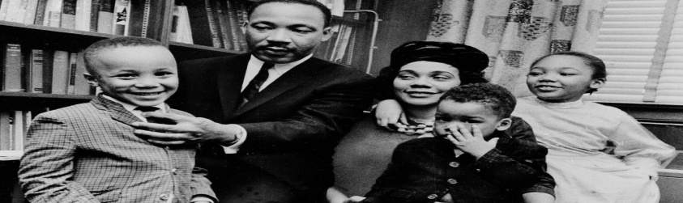
eH.td.zsJ.o;zSH'D;uxX.ch

rk>vGH>eHRvg,ElRtg&H.26oDrd>y>'D;uFdo&.w>xH.vd.td.zSd.

udFzddrd>y>o&.w>td.zSd. A4=7 [gcD

uFdzdvXtvDRwJR'D;touJ;yo.w*hRwz.'D;xD.uFdwvXySJRwz.
yuud;rd>y>vXvDwJpdvXub.[JxD.w>td.zSd.vDRI

uFdzdtr;oh.wz.yu[h.vDRrd>y>ph>uD;vDRI

vg,ElRtg&H.27oDrk>,J.eHRudFwtd.b.

